

Senior Procedures Manual
Queensland Rail

Documentation Details:

Document Author | Version | Release Date | Status | Comment
Michael Cleary | 1.0 | 20/07/2022 | Published
Michael Cleary | 1.1 | 29/11/2022 | Published | Added monthly reporting and staff onboarding sections. Updated agent monitoring section to reflect changes to dashboard and workflow priority.
Michael Cleary | 1.2 | 30/01/2023 | Published | Added brief overview of CHG processing.
Michael Cleary | 1.3 | 11/09/2023 | Published | Added section on signing into Jit.
Shane Kmet | 1.4 | 20/11/2023 | Published | Added section for ‘Additional Weekly Reports’
Michael Cleary | 1.5 | 20/11/2023 | Published | Updated section on weekly agent reporting.
Jarred Dahl | 1.6 | 21/11/2023 | Published | Added Attendance Process.
Shane Kmet | 1.7 | 22/11/2023 | Published | Replaced Powerplay with ‘Using Alcatel-Lucent OmniPCXRECORD’
Shane Kmet | 1.8 | 30/04/2024 | Published | Updated “Remaining Access” for requesting ‘ICT_Service_Desk_Team_Standard’
Shane Kmet | 1.9 | 01/05/2024 | Published | Updated Onboarding detail for VDI Access
Michael Cleary | 1.10 | 02/06/2025 | Published | Reworked “Monthly SLA Reporting” section.
Michael Cleary | 1.11 | 20/06/2025 | Published | Added “QR Last 12 Months” report

Table of Contents
Basic overview of role 5
Leadership Team Mailbox 6
Handover 7
Alarm Monitoring 8
SCOM 8
Control-M 8
Weekly QA 10
Using Alcatel-Lucent OmniPCXRECORD 11
Using CCSupervision 13
Agent Monitoring and Expectations 14
“Focused” Dashboard 14
No Owners 14
Work Order Priority 14
Interactions per Two Hours 15
Praise Process 16
Updating the IVR 17
Setting a new IVR 17
Setting the IVR back to default 17
Weekly Reporting 19
Agent Activity Monitoring 19
Service Now Data 19
Call Data 19
Interactions vs Calls 20
Cumulative CCSupervision and Email Reporting 20
CCS Reporting 21
Email Reporting 22
Combining the reports 23
Additional Weekly Reports – Agent Call Stats and Daily Call Stats (CCS) 23
Monthly SLA Reporting 25
CallData 25
FCR 25
Ticket Reopen 25
Ticket Reassignment 25
Ticket ReOpen ReAssignment Data 25
Speed to Answer SLA (Row 2) 26
Ticket Reopen SLA (Row 3) 26
Ticket Reassignment SLA (Row 4) 26
Call Abandonment Rate SLA (Row 5) 26
First Contact Resolution (FCR) SLA (Row 6) 26
QR Last 12 Months Reporting 27
File Location 27
Where to Pull the Data From 27
Onboarding New Service Desk Staff 28
Raising request to Renee 28
Raising IT System Access Requests 28
SAP Account 28
Elevated Privileges 28
Service Now 28
Email Access 29
VDI Access 29
Dell Wyse Access 29
Remaining Access 29
Attendance Process 30
Microsoft Shifts 30
CCSupervision 31
Attendance Spreadsheet – How to log the attendance 32
Wallboard 34
Logging into meet.jit.si 34
Applications and Links 35
Contacts 36
DXC Hobart Contacts 36
QR Account Resolver Contacts 36
Desktop 36
Desktop Tech Bar Hours 36

Basic overview of role
The work order priority for seniors remains the same as with agents, with the addition that all other items in this document are at the highest priority (e.g. the alarms and QA will always take preference over getting the general ticket workload completed).
The remainder of this document outlines the exact expectations of the role, but the core items are:
- Leadership Team Mailbox
This is an additional mailbox that serves as a central point of communication for the leadership team for internal desk matters.
- Handover
Passing information to and from the afterhours support team and ensuring the two teams transition as smoothly as possible.
- Alarm Monitoring
Monitoring multiple alarm systems to advise of any issues before they start generating issues for users.
- Weekly QA
Quality Assurance checks on all agents to ensure that all staff are following correct processes and
- Agent Monitoring and Expectations
Monitoring agents on a day to day basis to ensure that all agents are working on the task at hand and actioning items in a reasonable time frame.
- Survey Process
Processing negative surveys as the are submitted to ensure that any processes that need to be adjusted can be.
- Praise Process
Submitting praise through the points system to ensure a constant acknowledgement and rewarding of exemplary work done.
- Weekly Reporting
Collecting overall call and ticket volumes done by the team to verify if we are meeting the monthly quotas as laid out in the SLA agreement with Queensland Rail.

Leadership Team Mailbox
The leadership team uses the QR_Service_Desk_Leads@dxc.com as a collective point of contact for things like potential praises, tickets to raise in QA, or staff issues that need to be addressed at a team-level rather than on an individual basis.
To get access to this mailbox raise a Self-Service request to DXC.

Handover
At 7AM and 7PM there needs to be a handover email passed between the day and night team to make sure that the receiving side is aware of any potential issues that may appear, any tickets that may need actions during the shift, or any ongoing or major incidents that the team need to be aware of.
The email is titled “Queensland Rail Shift Handover (Morning/Evening) – DD.MM.YYYY”, with either morning or evening depending on the time of day the handover is being sent (i.e. “morning” for the 7AM handover, “evening” for the 7PM) and the date completed with the date the handover is being sent. There is a template email in the “Queensland Rail Seniors” team in Microsoft Teams.
The 3 sections that may require filling during the evening handover (as the only one that the day staff must complete) are the blank space above the “Mailboxes” section, the “Priority Incidents”, and the “Non-Priority Incidents” section.
- The blank space is used for any information about broader issues or information updates, e.g. a known issue with printing or an upcoming system outage.
- The Priority Incidents section is used to hand over all active P2s with a quick rundown of the issue and the actions being taken by the team.
- The Non-Priority Incidents section is used to handover all incidents (or catalog tasks) that require action in the evening shift.
There should also be a line-test call after the email is sent to the QR Service Desk phone number (07 3072 5000) to make sure that there are no line issues and to advise of anything put in the handover in case the team accidentally misses something in there.
On this desk we also have a running report on how much work is left over at the end of each shift. At the top of the “Senior Leadership Chat” in Teams is a tab labelled “QR Ticket Counts.xlsx”. Go to the relevant date at the end of your shift and update the 3 columns using the information from the “Focused” dashboard.

Alarm Monitoring

SCOM
SCOM is our server and application health monitoring tool that warns of any issues affecting the functioning of various systems. As the alerts in this system can self-heal we log any alert that reaches 15 minutes in new.
If on first run SCOM asks you to enter a server, the correct servers are CPTPRDMON112 and CPTPRDMON212.
To raise a SCOM alert into SNOW set the fields as the following:
- Caller: EventMonitoring QLR
- Contact Type: Event Monitoring
- Application Service: SCOM
- Configuration Item: Either the server name or SCOM if the server is not in SNOW.
- KB Article: KB0010884
For the description and short description select the alarm in the list in SCOM:
- Click into the “Alert Details” box at the bottom.
- Press Ctrl+A to select all the text and copy the whole thing.
- Paste that into the “Description” field in SNOW.
- Copy the first line of the new description and paste that into the “Short Description”.
Find previous tickets with the same description and assign the ticket based on those.

Control-M
Control-M is the monitoring tool for automated transactions in QR SAP and can be opened under your administrator account in the Citrix portal with the shortcut to “Control-M EMClient”.
After opening the app sign in with either your standard or admin account, both will work. Close any popup windows inside the application when it starts and select “Monitoring” in the left menu bar and then “Alerts” from the context menu on the right.
Once inside the alert window you will need to set up the following filters which can be done by hovering over the heading of a column and clicking the filter/funnel icon on the right: “Status” should be filtered to only show “Unread”; “Severity” should be filtered to only “Urgent” and “Very Urgent”; and “Control-M Server” should be filtered to only “CTMPRD”.
We triage all alarms in this system as they are raised, except the following:
- The hourly warnings: “The Secondary Control-M/EM Configuration Agent is not responding…”
- The bulk lot of alarms received at 2PM QLD time: “ONE OR MORE JOBS IN DAILY *** WERE NOT ORDERED”.
To triage any other jobs:
- Select the alarm in the list.
- In the right panel under the “Source” heading is a blue hyperlink to the SAP job.
- If the job is in any state other than error the alarm can be marked as read and ignored.
- If the job is in an error state it will need to be logged.
- Open \\corp.qr.com.au\app\ControlM in File Explorer inside the environment.
- Search that folder for the job name.
- You should get a result of one or more Word documents, open the most recent and it will outline the steps to take. We only need to pay attention to any steps that involve an escalation point, we are not responsible for rerunning or correcting the issues themselves. Pay attention to the wording, even at this stage not all alarms need to be logged.

Weekly QA
It is a requirement that every agent has five calls a week reviewed, four solely based off the work done in ServiceNow itself and one on the work done in ServiceNow along the content of the phone call that generated it.
In addition to the above, each agent should have one call live monitored (i.e. as the user is on the phone) once per month. This is per agent, not per senior, so you will be expected to liaise with the rest of the leadership team to ensure that we aren’t doubling up on the work done both to not waste our time and to not cause undue stress on the agents. This live call QA will replace the recorded call QA for the week that it takes place in. The point of the live call QA is to properly assess what the agent is doing on the phone call, e.g. are they taking live notes, are they using novel steps that should either be corrected or can be replicated to other agents, etc.
The recorded phone call should be picked at random from a call answered by the agent over the preceding and current weeks, and the remaining four tickets should be selected from those opened by the agent over the same period with the Contact Type of “Phone”.
The calls are listened to using Alcatel-Lucent OmniPCXRECORD whose instructions for use are in the section Using Alcatel-Lucent OmniPCXRECORD section.
The reviews themselves are recorded in a spreadsheet in the “Queensland Rail Seniors” team in Microsoft Teams, it is named “QR Reviews Agents” and it is pinned to the top of the team page. All agents have a tab in that spreadsheet, and the headings and content are self-explanatory and will not be expanded on here.
In the “Reporting” dashboard in SNOW on the “Weekly Reporting” tab (the landing tab) there are two filters of note:
- Incidents Opened This Week - Phone - Service Desk by Agent - Reviewed by EARLY SHIFT Senior
- Incidents Opened This Week - Phone - Service Desk by Agent - Reviewed by LATE SHIFT Senior

These reports break the agent list into two halves and creates a table of contact type for easy reporting on phone call tickets as the primary focus. Tasks should also be reported on but have no easy filter. The “A” and “B” columns are alternated between Senior for review weekly. There is also a bi-weekly catchup between seniors to compare notes and ensure consistency in reviewing.

Using Alcatel-Lucent OmniPCXRECORD
OmniPCXRECORD is used to listen to recordings of all calls to the Service Desk both ingoing and outgoing.
Access is via URL 10.0.211.180/OmniPCXRECORD/Searches.aspx signing into the application with the username:password combo “PhoneExtension#:’YourPassword” you will then be greeted with the interface of a template allowing the searching of call data. To filter for call recordings required, you will need to provide some search criteria details.
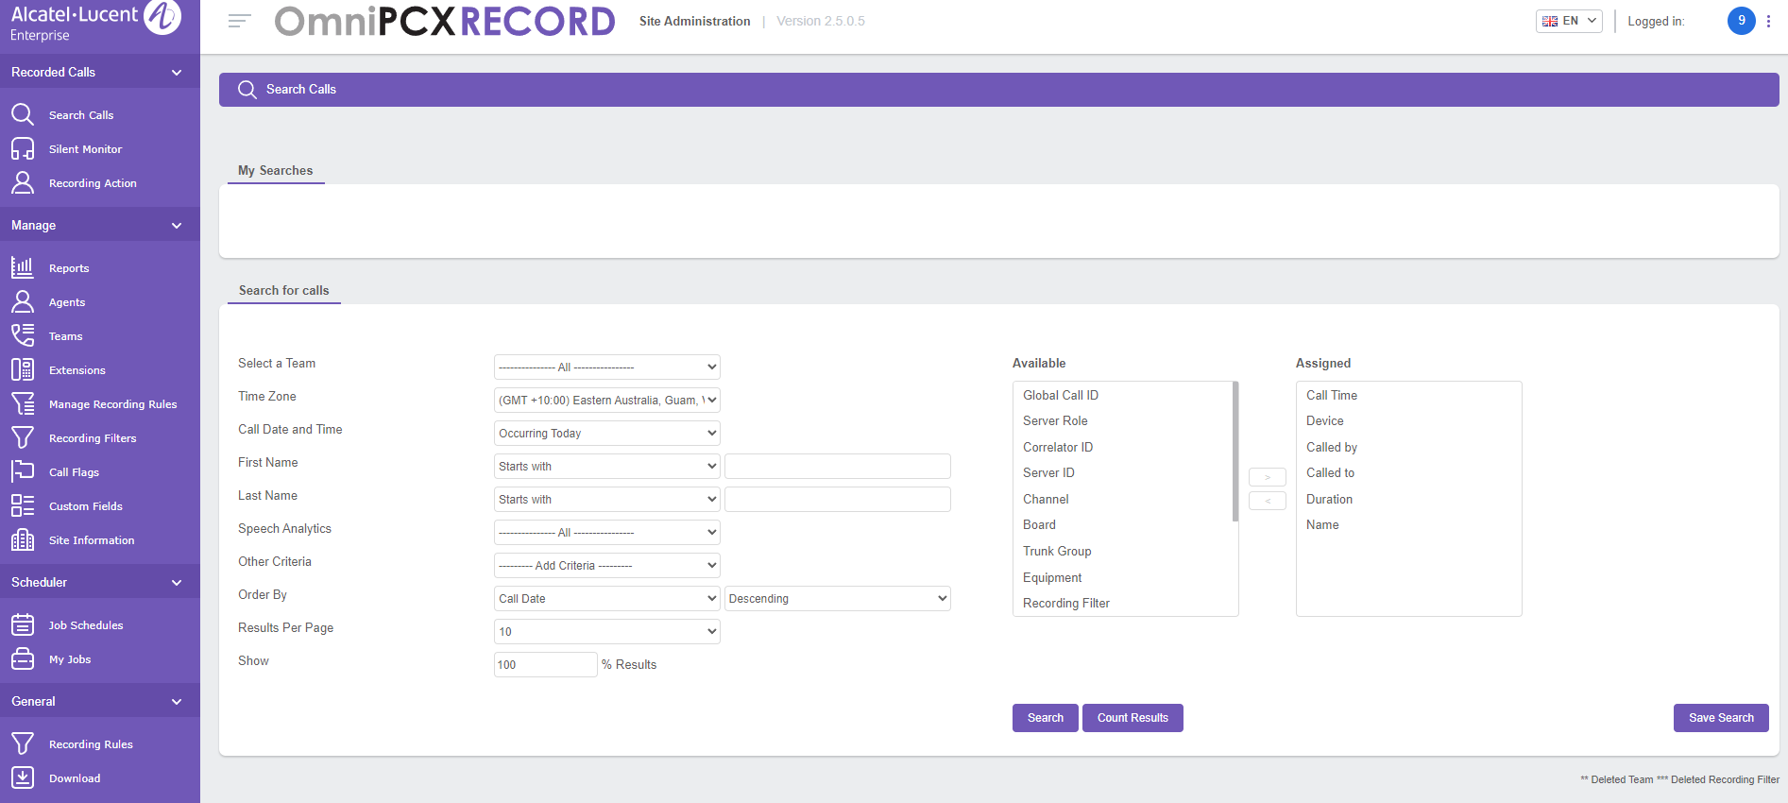
- Under the “Select a Team” section find a list of the various DXC Service Desk teams. For Queensland Rail, select “QR”
- Under the “Call Date and Time” section select the desired time frame of which you need to search for calls over
- Under the “First Name” and “Last Name” sections, select an option (eg Starts With) and enter the Agents name in the text box provided.
- Once your search criteria is set press “Search” at the bottom of the template to start the search
Once the results are loaded, you will be presented a list of all calls showing select the recordings matching your search criteria.
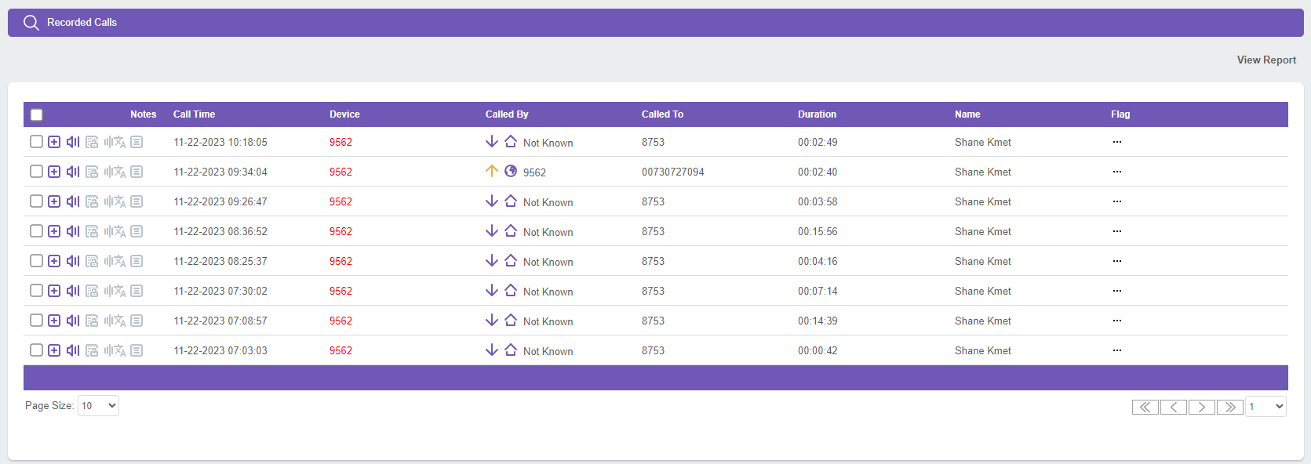
To play the required recording, press the “Audio Call” icon and select “Play”
If needing to download a copy of the recording, select the “Download File”
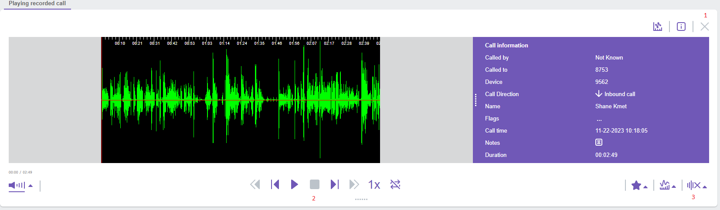
- Close and remove the current call.
- Payback controls. (Play, stop, seek, playback speed (1 to 4x) etc)
- Skip white space (pre-call and on-hold).

Using CCSupervision
CCSupervision is used to monitor and report on the phone queue and phone calls statistics. The main uses for it on the Queensland Rail account are weekly and monthly reporting (which has it’s own section so will not be elaborated on here) and assisting with the agents around the office working on soft phones because when there is a network flutter on anyone’s PC their phone will go into an “Out of Service” state and requires server-side intervention to allow the agent to log back in.
There is a site-wide Teams chat (“CSS Force Log-off Requests Chat (???)”) that is a central point for people to request to be “booted” from the phone queue in the case their phone goes into the Out of Service state. The wallboard also shows the state of any given phone in our team in the bottom left of their nameplate.
To “boot” a phone in CCSupervision:
- Open CCSupervision.
- Sign in with the username:password “SEE MARTY”.
- Open the “Real time” menu from the top bar.
- Click the “Agent” option from the Real Time menu.
- In the top left drop-down list under “Agent”, select the person that you want to remove from the queue.
- Verify that their “Current status” is set to “Out of Service”.
  - If it is not, have them recheck everything from their end and escalate the issue in the CCS Force Log-off chat.
- Click “Other Actions…”.
- Click “Force Log-Off”.
- Advise the agent that the device is ready to be signed into again.

Agent Monitoring and Expectations

“Focused” Dashboard
There is a second dashboard in SNOW that is very similar to the Service Desk v3 dashboard used by agents with a few additions to make tracking additional senior workloads. As with the agent dashboard this dashboard shows the workload for everyone, ticket assignments levels, and customer ticket updates. In addition there are also counters for incident and catalog tasks that will show tickets that are approaching the threshold for sending out the SLA breach emails so that you can try to get ahead of them so the team isn’t swamped with urgent work.
There is also second tab on this dashboard containing less-commonly used filters that are also good to keep an eye on including total ticket counts, active P2s, and aged tickets assigned to Service Desk.
This dashboard is a ‘living’ dashboard and is modified on an as-needed basis, but the core layout will remain the same as the agent dashboard.

No Owners
No owners should be handed out to the team in whatever distribution ends with each agent having roughly the same number of tickets assigned to them. No owners can be assigned to agents on leave as the work order is based around a shared team workload and not an individual workload.
We should aim to have them allocated to individual agents within half an hour of them being assigned to the Service Desk queue.

Work Order Priority
As a senior you are required to make sure that the agents are following the prescribed work order priority laid out in the Induction Manual provided to them on starting, copied below for convenience:
- SLA breach alert emails.
- Requests and incidents that are closed and have been updated by the user.
- Requests and incidents that have been updated by the user.
- Actionable VIP tickets.
- Assigned to Service Desk older than 2 Days.
- Counting down SLA
- Not updated today
- Emails
The “Focused” dashboard in SNOW (see top of this section) has filters set up to make monitoring this easier.

Interactions per Two Hours
On both the “Focused” and “Service Desk v3” dashboard there are second tabs that track how many tickets interactions each agent has made with SNOW over the last two hours. Please keep an eye on this to make sure there are no outliers.

Praise Process
DXC implements a Staff Rewards system to recognize and reward Service Delivery Staff on good support provided to supported DXC Clients and other related support streams. This is often received via customer feedback and interactions; via phone, email, ServiceNow Survey Responses etc.
The P.R.A.I.S.E system comprises of the following resources, in reporting, documenting and communication when submitted P.R.A.I.S.E for the recognized agent.
The P.R.A.I.S.E Register (see Applications and Links section) is used to document P.R.A.I.S.E that is completed and submitted for the recognized staff member. Information require is shown below, including Date raised, SDA, Level of Reward, from which client, whether emailed and printed, logged in ‘Reward and Recognition’, Reward Given and some Feedback Text.
This P.R.A.I.S.E Register (see Applications and Links section) site allows for the submission of P.R.A.I.S.E to the receiving agent. This also allows the agent to redeem their accumulated points for services and products.
To Reward a colleague, select the Recognize option. A selection of possible agents is presented, select the agent that is to receive a P.R.A.I.S.E reward.
You can either search an agent by name, or those that full under the same team as yourself (My Work Circle). This will show recent recognized agents, or your fellow team members. Click on the agent’s name, this will select the agent to continue. This will be represented as 1 or more agents selected. Then click on Next.
Select “Deliver” on the next screen and follow the prompts selecting options as appropriate. One you arrive on the page with the point values, select the appropriate reward (the default option is Sapphire, this will be used on almost all P.R.A.I.S.E.).
There is a template in the “Queensland Rail Seniors” team in Microsoft Teams to use to fill guide what is put into the form submitted in the next page. This template should also be printed for placement on the wall.
There is a template in the “Queensland Rail Seniors” team in Microsoft Teams that is to be emailed out for every P.R.A.I.S.E to highlight good work being done at the Service Desk level.

Updating the IVR
The phone IVR (pre-amble before a user hears before joining the phone queue) can be updated in the case of widespread issues to try and avoid users reaching an agent for something that is being fixed at the network level.

Setting a new IVR
Before setting an IVR, ensure that it has been approved by the Account Run Lead or similar (see contact section of Induction Manual).
To record and set a new IVR, follow the below steps:
- Dial *0# (star zero hash) on your Alcatel handset
- Press Record to change the current IVR
- Enter the VG number for QR (829) and press “Apply” and “Apply” again
- Press Start recording to begin your recording.
- Record the new IVR message in accordance with the template below:
Currently users are experiencing <<summary of issue in plain English>>. We are aware of the issue and are working to restore services as soon as possible. For all other issues please hold the line and a representative will be with you shortly.
- When you have finished recording press “Stop”.
  - To listen to the message you have recorded press “Listen”
  - To re-record it press Record again
- Once you are happy with your recording press “Apply”, the system will ask you to enter a filename (maximum of 6 characters). Enter the last 6 digits of the Major Incident case number as the file name
- Press “Apply” after entering reference number, it'll ask to enter memo, enter the reference number again and then “Apply”. A message should appear confirming upload. Feel free to hang up.
- Call SD number (02 9269 2077) and confirm message has successfully uploaded.
It is best practice to remove the customised IVR message that you created by repeating the above but press “Delete” instead of “Select”.

Setting the IVR back to default
Once the underlying issue has been resolved, the IVR can be set back to the default intro. To do that, follow these steps:
- Dial *0# (star zero hash) on your Alcatel handset.
- Press “Download”.
- Enter the VG number for QR (829) and press Apply.
- User the arrow keys to locate the original message (this should always be "qrwelcome selected").
- With the original message selected press “Select”.
The IVR will now be set to the original and you may hang up.

Weekly Reporting
Links to all reports can be found under the Applications and Links section of this document.

Agent Activity Monitoring

Service Now Data
Every Monday an email is sent to the QR_Service_Desk_Leads@dxc.com with Service Now exports for all tickets updated, opened, or closed for the preceding week. The email is named “Activity Monitoring Report Bundle - This Week and Last Week” and contains 5 spreadsheets.
A spreadsheet can be found in Microsoft Teams, in the “Queensland Rail Seniors” team shared files directory under the “Reporting > Weekly Agent Reporting” subfolder named “AgentReporting-Combined.xlsx”
When the email arrives Monday morning the existing data in the spreadsheet needs to be replaced with the new data. Delete all data in the tables of the tabs below (all coloured blue in the spreadsheet) and paste the data from the spreadsheet in the weekly email:
Spreadsheet | Tab
Updated Last Week (SCTASK) | Updated Tasks
Updated Last Week (INC) | Updated Incidents
Updated Last Week (Survey Results) | Surveys
ResolvedClosed Last Week (RITM & INC) | Closed
Opened Last Week (RITM & INC) | Opened
Chats Taken Last Week | Chats
Once the data has been updated/replaced go to the “Data” heading in Excel and click “Queries & Connections”. In the new panel that has opened on the right of the screen, click the refresh icon that appears when hovering over “Processed – Per Hour Per Day” as well as the one over “Formatted Closed Ticket”. Once both of these finish refreshing, refresh the “Update by Type” query in the same manner. Once this has finished refreshing, move to the “Results” tab (coloured white).
On the Results tab, right click on the two pivot tables and the two graphs in the “Daily Ticket Interactions” section and click “Refresh”.

Call Data
Go to the “Call Data” tab in the “AgentReporting-Combined.xlsx” spreadsheet (coloured yellow).
In the output from "Additional Weekly Reports – Agent Call Stats and Daily Call Stats (CCS)" section, go to the “Agent” tab. Highlight all rows containing agents from column B (“Agent”) to column W (“Logged in”) inclusive. Copy the highlighted cells.
Paste these cells underneath the existing data in the “Call Data” tab in the “AgentReporting-Combined.xlsx” spreadsheet, starting from column C (“Agent”). Delete any rows where the agent did not sign into the phone (will be 0 for all values in that row. Add the date of the preceding Friday into column A (“Week Ending”) for each remaining row for the new data.
Fill in the “Days Worked” column for each new row with the number of days the agent worked in the week where they logged into the phone system.
On the Results tab, update the “Week Ending” filter directly under the “Call Stats” heading to the most recent week.

Interactions vs Calls
Go to the “Interactions vs Calls” tab in the “AgentReporting-Combined.xlsx” spreadsheet (coloured red).
At the bottom of each of the three tables (“Inbound Calls,” “Ticket Interactions,” and “Interactions Minus Calls”) create new rows for each day in the previous week.
Fill in new rows in the “Ticket Interactions” table with the data from the “Daily Ticket Interactions” table from the “Results” tab, matching each agent and date with its pair in the corresponding table.
For the “Inbound Calls” table you will need the data gathered from the "Additional Weekly Reports – Agent Call Stats and Daily Call Stats (CCS)" section. Open the “Detailed_report” tab of the CCS export. Copy the numbers in column C (“ACD served calls (total)”, example below) into the corresponding agent/date in the “Inbound Calls” table of the “AgentReporting-Combined.xlsx” spreadsheet, going down the full “Detailed_report” tab to ensure that every agent has had their data copied.
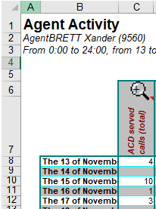

Cumulative CCSupervision and Email Reporting
As part of the monthly reporting we are required to pull call data from CCSupervison (hereafter referred to as CCS). This data is only available to be pulled for 30 days and is time consuming to do in bulk so doing it in segments over the course of the month is preferable if not required depending on when the month starts.
The link to the spreadsheets that require filling out can be found in the Applications and Links section below. Installing the application is outside the scope of this document, but the required files can be found in the “Queensland Rail Seniors” team files in Microsoft Teams.
Inside the “Snapshot and reports” folder there are folders for each year and each year folder contains monthly folders. Each monthly folder will have a handful of spreadsheets, one for the month as a whole (naming format “QR Service Desk Monthly – MONTH – YEAR.xlsx”), and one for each week or part thereof in the month (naming format “QR Service Desk Weekly Breakdown – Weekly START DATE – END DATE YEAR.xlsx”).

CCS Reporting
Open the week that you want to perform the reporting for and open the CCS application. Do not close the blank Excel spreadsheet that opens with CCS. The log in for CCS is the same as POWERPlay, username “tturner” and password “Connect1”. To open the reporting function inside CCS, go to the “Statistics” heading option, expand “Excel” and select “Pilot”.
Inside the new “Output of Pilot statistics” window select “Q Rail Backup” from the list of “Available Pilots” and click “Add” to move it to the “Selected Pilots” box. Under “Available templates” select “QR” and press “Add” to move it to the “Selected templates” box. Set “Types of edit” to daily and “Output granularity” to “1 hour”. Set “Start date for edit” to the date you wish to run a report on. Press “Validate” to run the report.
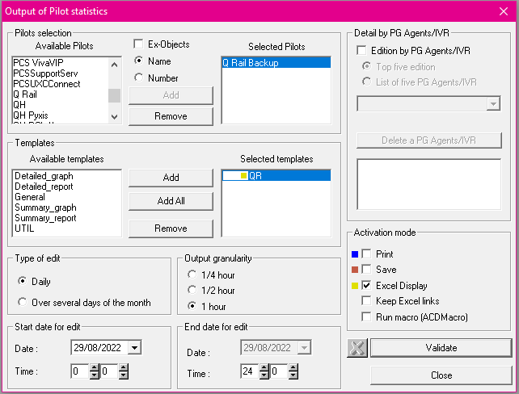
Press “End” or “OK” on any runtime errors that appear in Excel. Continue only pressing these buttons until the bottom left of CCS shows for “For help, press F1”. Copy the contents of the cells in a rectangle from F7 to O9 inclusive, and paste the contents in the relevant day in the already open “QR Service Desk Weekly Breakdown – Weekly ***” spreadsheet, starting on column F.
Continue the above on all dates through to (but not including) the current date. Any cells in the weekly spreadsheet in columns K, L, M, N, or O that have “#DIV/0!”, click the cell and type 0 (zero) before hitting enter.

Email Reporting
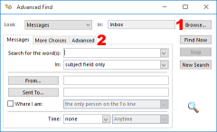
For email reporting, the easiest way to pull the data is with the Advanced Find feature. To access this, click into the search bar, expand “Search Tools” from the menu ribbon, and click “Advanced Find…”. You will have to open this while having the IT Service Desk mailbox up as it can only be used to search the current mailbox.
Press “Browse…” in the top-right (position 1 in the screenshot) and tick “This Week” under “Inbox” under “ITServiceDesk@qr.com.au” and tick “Search subfolders” before pressing “OK”. Ensure that “Inbox” is unticked.
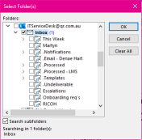
Go to the “Advanced” tab (position 2 in the screenshot). On this tab type “Received” in the text field at the bottom of the window, set the “Condition” to “On” and the “Value” to the date you are reporting on in DD/MM/YYYY format. Press Enter twice to add the filter to the criteria and start the search.
Once the results populate, select one and press Ctrl+A to select all the emails. Press Enter and you will get a warning prompt about opening a lot of files, note the number of emails in this warning and select “No”.
In the weekly spreadsheet referenced in previous sections, put the number of emails against the filtered day in column D (“Emails actioned”).

Combining the reports
At the end of each week (or month if the week spans multiple) the data needs to be collated into “QR Service Desk Monthly – MONTH – YEAR.xlsx” spreadsheet in the same folder as the weekly spreadsheet.
Ensure that there are no “#DIV/0!” values in the bottom table between cells F36 and O42 (or whichever is the final row for the current month) in the weekly spreadsheet. If there is, go back to the table higher in the spreadsheet with the daily stats and replace any “#DIV/0!” values with “0”. The bottom table should automatically update.
Copy the bottom table from D36 to O42 (or whichever is the final row for the current month) and paste it into the into “QR Service Desk Monthly – MONTH – YEAR.xlsx” spreadsheet in row B next to the corresponding date. The green columns will automatically fill as will the red totals row.

Additional Weekly Reports – Agent Call Stats and Daily Call Stats (CCS)
At the beginning of each new week (Monday), a Senior Agent will provide the past weeks data for Agent Call Stats and Daily Call Stats to the QR Service Desk Team Lead and 2IC via email. This information is created in a similar process as detailed in the section “CCS Reporting” above.
To open the reporting function inside CCS, go to the “Statistics” heading option, expand “Excel” and select “Agent”.
Inside the “Available Agents” box, select all SDA names for the team and click “Add” to move it to the “Selected Agents” box. Next select all options in the “Available Templates” box and add to the “Selected Templates” box. Set “Type of edit” to “Over several days of the month” then set the Start and End date for the report (This will be for the past week of Monday to Sunday). Once all report variables are set, click on “Validate”. Once report completes, save the created report to a suitable location for emailing.
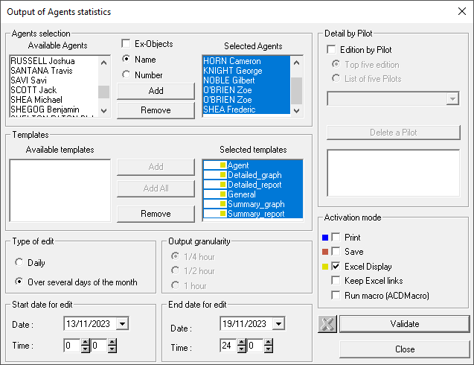
With the Agent Call Stats report completed and saved, next update the “QR Service Desk Monthly – MONTH – YEAR.xlsx” spreadsheet for data up to the previous day (Sunday). Follow the process as per “CCS Reporting” above” to ensure the Call Stats are updated for the full previous week.
With both reports completed, email the reports to the QR Service Desk Team Lead and 2IC.

Monthly SLA Reporting
The monthly reporting spreadsheet template can be found in the “Queensland Rail Seniors” team in Microsoft Teams under the “Reporting” folder (“YYYYMM SLA DATA Service Desk - QLR.xlsx”). At the start of each month we are required to complete this spreadsheet and email it to Raniel Iardizabal (raniel-adrian.dir.lardizabal@dxc.com, email is to be sent by either the TL or the 2IC).
The below tabs need to be updated with details from various systems:

CallData
This data is to be copied from the “QR Service Desk Monthly – MONTH – YEAR.xlsx” spreadsheet which can be found in the “Queensland Rail Seniors” team in Microsoft Teams under the “Reporting > Snapshots and Reports (FAPSYD)” folder.
The right column needs to be updated to the correct month name and the table needs to be filled with the totals from the relevant column in the “QR Service Desk Monthly – MONTH – YEAR.xlsx” spreadsheet.

FCR
The data from the “FCR - Phone Contact Type” and the “Password Reset Last Month” filters in Service Now need to be exported as spreadsheets and the data put into one table on the FCR tab. The columns won’t line up exactly with the naming, but the data is still fine to be appended to each other. These filters can be found on the “Reporting” dashboard in Service Now on the “Monthly Reporting” tab.

Ticket Reopen
This information is provided by a member of the reporting team via email to the team lead and 2IC, the entire contents of the provided spreadsheet is to be copied into our SLA reporting spreadsheet.

Ticket Reassignment
This information is provided by a member of the reporting team via email to the team lead and 2IC, the entire contents of the provided spreadsheet is to be copied into our SLA reporting spreadsheet.

Ticket ReOpen ReAssignment Data
This information is provided by a member of the reporting team via email to the team lead and 2IC, the entire contents of the provided spreadsheet is to be copied into our SLA reporting spreadsheet.

A list of all updateable SLA fields on the “SLA Results” tab is below, fields that require manual updates are highlighted in RED. All other fields will be automatically updated when the various tabs are populated with data.

Speed to Answer SLA (Row 2)
Total Units (I2) – Total number of calls answered in the month (taken from CallData tab).
Units Met (J2) – Total number of calls answered within SLA in the month (taken from CallData tab).
Units Missed (K2) – The difference between the above two. This will be prefilled with a formula once the last two items are complete.

Ticket Reopen SLA (Row 3)
Total Units (I3) – Total number of cases in the month (taken from “Ticket Reopen” tab).
Units Met (J3) – Total number of cases not reopened in the month (number of “0” reopens, taken from “Ticket Reopen” tab).
Units Missed (K3) – The difference between the above two. This will be prefilled with a formula once the last two items are complete.

Ticket Reassignment SLA (Row 4)
Total Units (I4) – Total number of cases for the month (taken from “Ticket Reassignment” tab).
Units Met (J4) – Total number of cases with 3 or less reassignment
Units Missed (K4) – The difference between the above two. This will be prefilled with a formula once the last two items are complete.

Call Abandonment Rate SLA (Row 5)
Total Units (I5) – Total number of calls presented in the month (taken from CallData tab).
Units Met (J5) – Total number of calls answered within the month (taken from CallData tab).
Units Missed (K5) – Total number of calls that were true abandons (taken from CallData tab).

First Contact Resolution (FCR) SLA (Row 6)
Total Units (I6) – Total number of tickets in the SNOW filter “FCR - Phone Contact Type” added to the total number of tickets in the SNOW filter “Password Reset Last Month”. These filters can be found on the “Reporting” dashboard in Service Now on the “Monthly Reporting” tab.
Units Met (J6) – Total number of tickets in the SNOW filter “FCR - Phone Contact Type FCR True” added to the total number of tickets in the SNOW filter “Password Reset Last Month”. These filters can be found on the “Reporting” dashboard in Service Now on the “Monthly Reporting” tab.
Units Missed (K6) – The difference between the above two. This will be prefilled with a formula once the last two items are complete.

QR Last 12 Months Reporting
The “QR Last 12 Months” report gives a long-term look at the trends for certain data points (primarily focused around Service Desk workload), and has expanded beyond the initial scope of prior 12 months as new data has been added.

File Location
QR Last 12 months.xlsx

Where to Pull the Data From
All of the data can be found at the below locations/links, the only one that needs any process is the AHT stat which has steps included:
Self Service Requests Direct to SD | Self-Service Requests that Open with Service Desk
Self Service Incidents | Self-Service Incidents
Inbound Calls | Snapshots and Reports (FAPSYD)  Navigate from the above directory to the correct “YEAR”/“MONTH” folder. E.g. for the month of July 2025 you would need to navigate to “2025/07 Jul”. Open the file starting with “QR Service Desk Monthly”.  The value required is the total for “Calls Presented”, found in cell “S10”.
Outbound calls | Report on all SD agents for the month in CCS and enter the total from the “Agent” tab.
Total Calls | Calculated Automatically.
Emails | Snapshots and Reports (FAPSYD)
Live Chats | Chats Taken (Last 3 Months)
Password Resets | Password Resets by Month
Customer Contacts | Calculated Automatically
Agent Interactions | AgentReporting-Combined.xlsx  Open the “Interactions vs Calls” tab.  In the “Ticket Interactions” table highlight all cells with values in rows for the month you are interested in. E.g. for July 2025 you would select all the numbers in every person’s column for each row in the month. Cells without values can be selected with no negative repercussions, so you can click-and-drag from the top left value to the bottom right value or similar.  The value needed is the sum of all the smaller values, which can be found next to “Count: ” in the bottom right corner of the Excel window. For July, this value would be 8338.
Agent Interaction Change from Previous Month | Calculated Automatically
AHT | - Report on all SD agents for the month in CCS.  - Copy all numbers from the “Inbound calls” column in table on “Agent” tab in the report to the “Calls” column in the table on the “AHT Calculator” tab in the “QR Last 12 Months” spreadsheet. (Remote desktop role from data)  - Copy all numbers from the “AHT” column in table on “Agent” tab in the report to the “AHT” column in the table on the “AHT Calculator” tab in the “QR Last 12 Months” spreadsheet.  - Copy the value under “Monthly SD AHT” into the “Data Table” tab in the “QR Last 12 Months” spreadsheet.
AHT * | Calculated Automatically (Needed to Correctly Display on Graphs)
Email INC | Incidents Opened by Service Desk by Contact Type
Event Monitoring INC | Incidents Opened by Service Desk by Contact Type
Phone INC | Incidents Opened by Service Desk by Contact Type
Self-Service INC | Incidents Opened by Service Desk by Contact Type
Walk-in INC | Incidents Opened by Service Desk by Contact Type
Web INC | Incidents Opened by Service Desk by Contact Type
Total Incidents Opened by Service Desk | Calculated Automatically
INC Resolved | Incidents Resolved by Service Desk
SCTASK Closed | SCTASK Closed by Service Desk
Closed/Resolved | Calculated Automatically

Onboarding New Service Desk Staff

Raising request to Renee
Before any QR account creation begins, Renee Dunstan will need to work with HR to set up things like training and getting a service number.
Fill in the below document (under Queensland Rail Seniors>Documents>General>Onboarding in the “Queensland Rail Seniors” files) and email it to rdunstan@dxc.com. Ensure that the new employee is checking their emails constantly for the incoming email from Renee or HR with links to training etc., this will need to be completed before the IT account creation can begin.
Qld Rail_ DXC BAU Onboarding - Request for O Account Form v1.1.xlsx

Raising IT System Access Requests

SAP Account
Raise a “SAP Support/Project Access” for the team to grant SAP access.
The Access Period is “Date delimited” from the current date to the cessation date.
The system that access is required in is “Service Desk Access: …”.
Where the access is required is “Other”.
We do not need to be able to move or approve transports.

Elevated Privileges
Raise an Elevated Privileges request for approval to be added to the following groups:
- Clearpass_OnboardUsers
- ClearPass_Receptionist
- Domain Users
- DXC_Users_Reporting_Admin
- ICT_Service_Desk_Team
- ICT_Service_Hub_Team
- Nexthink_Service_Desk
Raise a second Elevated Privileges for admin access to the Exchange/Intune. This is to be assigned to DXC Infra Active Directory.
Raise a third Elevated Privileges request for access to Airlock. This is to be assigned to DXC Security End Point Protection.

Service Now
Raise a Software Access Request for access to Service Now as a member of the IT Service Desk.

Email Access
Raise an Email Services Request for access to the ITServiceDesk@qr.com.au email address.

VDI Access
Raise a remote network access request to have both a dedicated VDI and non-persistent VDI added to the account. Note that for After Hours SDA requests, request only a non-persistent VDI.

Dell Wyse Access
Raise an Other Request for access to Dell Wyse console (follow KB0020898 to grant access).

Remaining Access
Raise an Other Request for access to the following group:
- ICT_Service_Desk_Team_Standard

Attendance Process
This document is for the Leadership Team of Queensland Rail on how to log attendance for the Queensland Rail Service Desk.

Microsoft Shifts
- Locate the Shifts app within the Microsoft Teams application.
- Listed under the Schedule tab will be everyone’s start times, end times and lunch times.
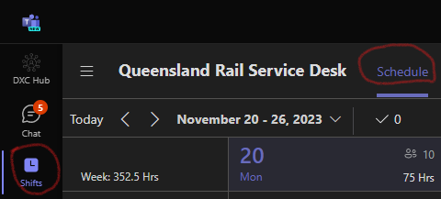

- Make sure that the Week has been selected and Team Shifts and People are ticked under the View options:
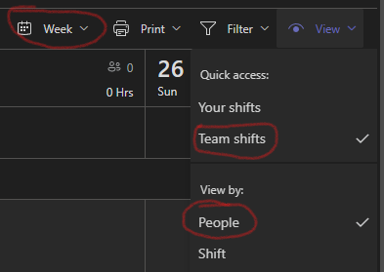

- The shifts should look like the below:
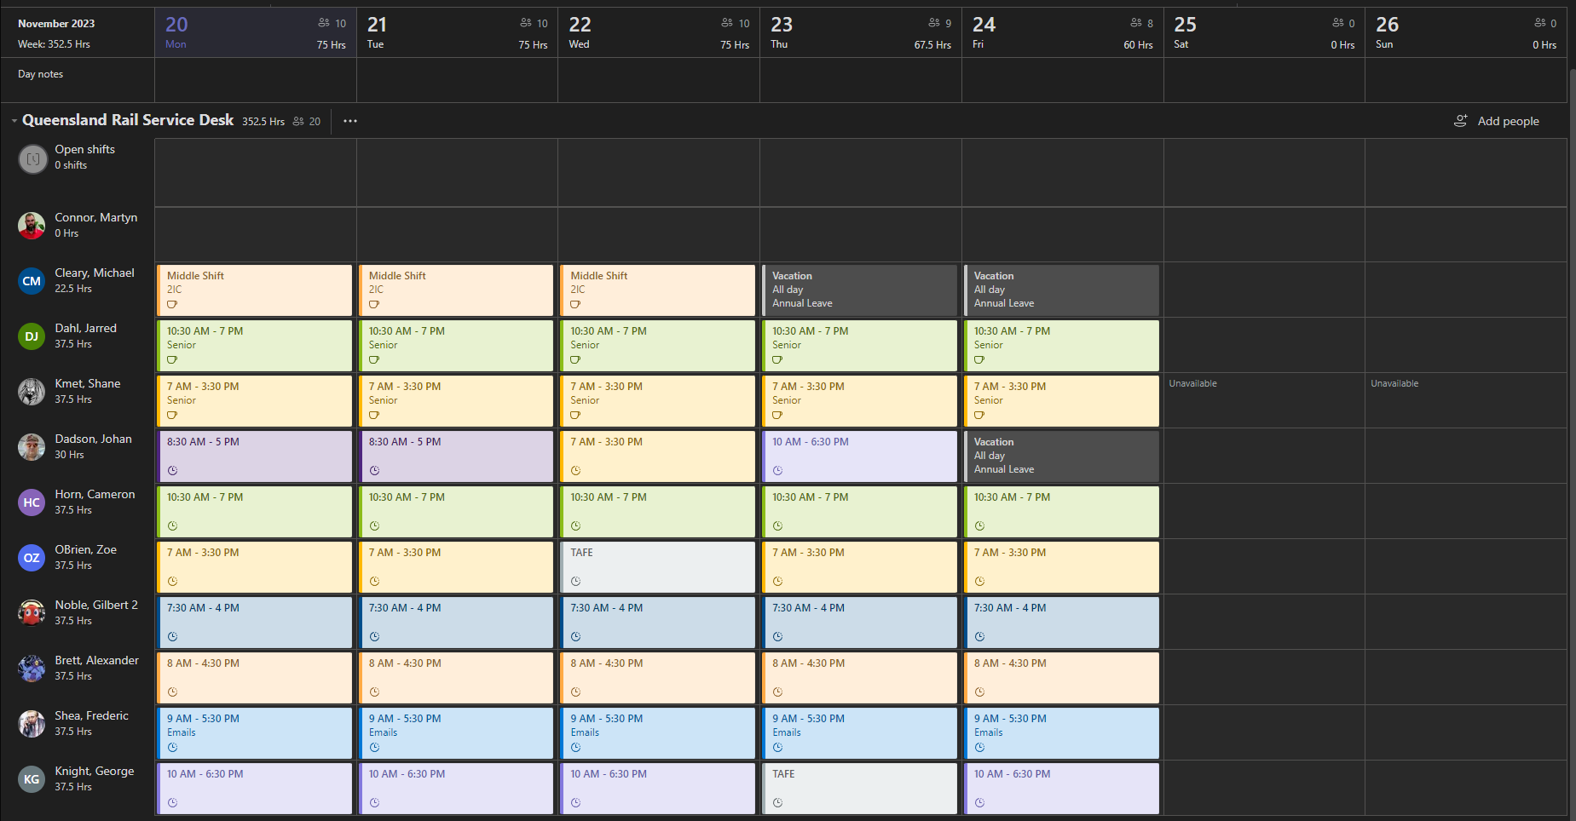
- Anyone who has logged onto the Cisco Phone late or is not at their desk at these times should be considered late. Furthermore, anyone who has sent a message to the Early Shift Senior and the Team Leader should be listed as either late or off for the day depending on the circumstance.

CCSupervision
You can check Cisco login times via the CCSupervision application.
- Open the CCSupervision app.
- Once logged in, Navigate to Real time > Agent.
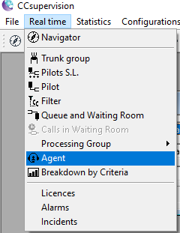
- Once here, locate the agent under the Agent tab and select them and you will see the Log-on time under the Statistics Since Log-on.
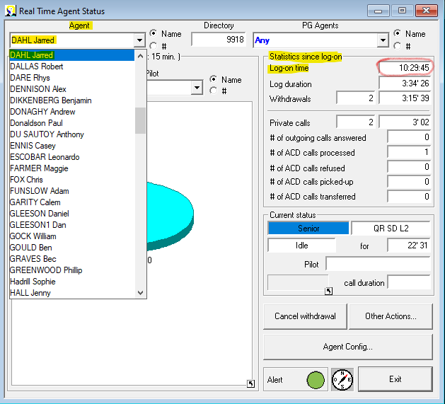

- Anyone who has the Log-on time after their Shift time is considered Late. (Depending on a couple of exemptions such as, if it is only a couple of seconds after their shift time, if they are having troubles logging into the phone, if they are at their workstation.

Attendance Spreadsheet – How to log the attendance
The Attendance Excel Spreadsheet is listed in the Queensland Rails Senior’s Teams within the Microsoft Teams application.
- Open Microsoft Teams and navigate to the Teams tab on the left hand side.
Once here – Open General listed under Queensland Rail Seniors.
Under General open the Files tab on the top of the app and navigate to the QR Draft Roster V1 (1).xlsx file.
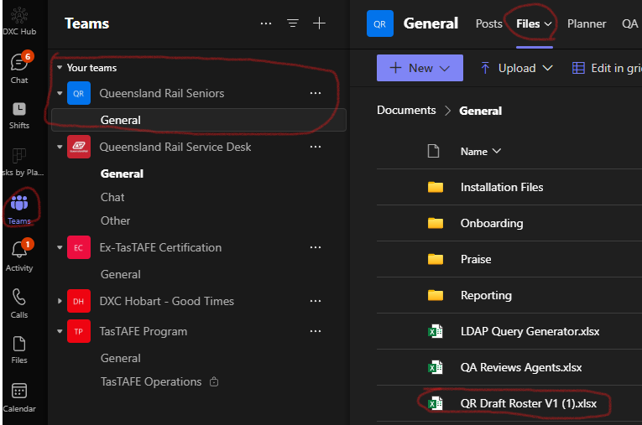
Spreadsheet should look like this:
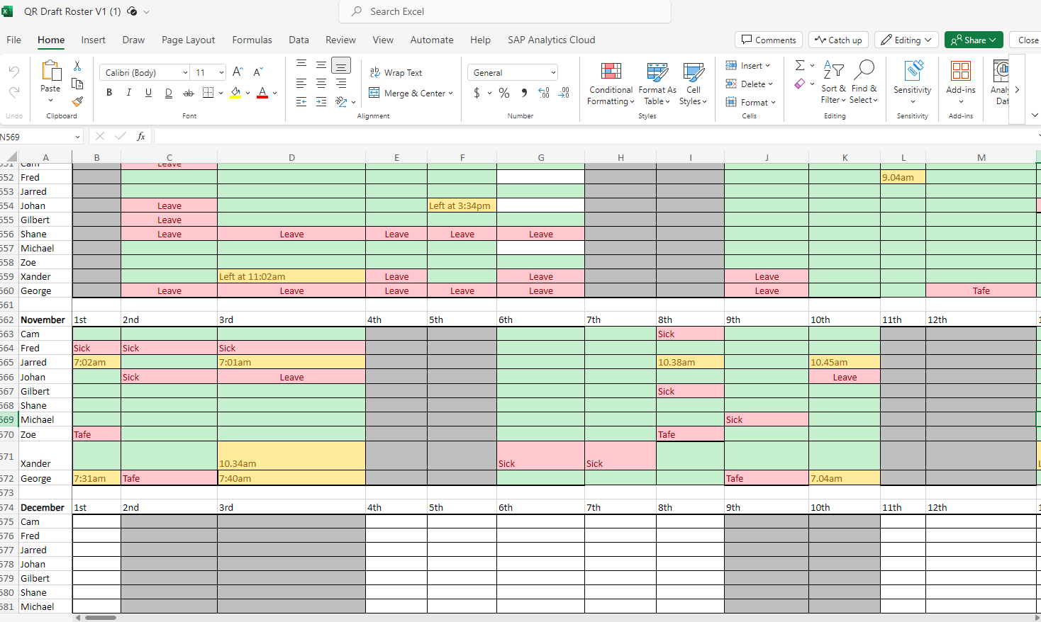
- Mark the attendance with the following colors depending on the circumstances:
RED – Agent is absent. – List the reason the agent is away that day (Example, Sick if on personal sick leave.)
YELLOW – Agent is late/left early. – List the time the Agent was late / left early.
GREEN – Agent is on time.
Use the Cell Styles for color coding:
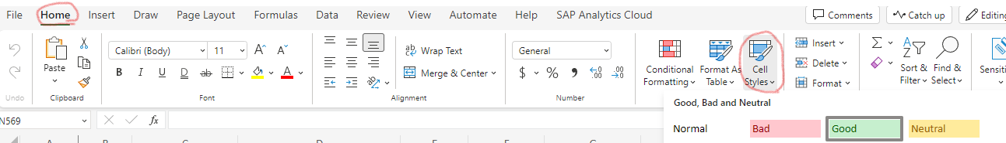

Wallboard
The wallboard address is http://10.195.196.139:9060/wbm/displayPanel.htm?name=QR and it will only work when connected to the DXC network, either via one of the non-guest WiFi networks or via AppGate. Wallboard management settings can be found under http://10.195.196.139:9060/wbm/.

Logging into meet.jit.si
The wallboard is streamed via https://fairmeeting.net/QueenslandRailwallboard. The password should be set to “Waterfall2022”.

Applications and Links
CCS reports | \\FAPSYD04.aus.local\group\mvsms_grp\Queensland Rail\Snapshot and reports
Praise Register | https://dxcportal.sharepoint.com/:x:/r/sites/HobartCoEPraiseTracking/_layouts/15/doc2.aspx?sourcedoc=%7BB03A7B26-8576-4E79-BDC1-437D87A9FAA7%7D&file=2022%20Praise%20Register%20-%20June%2022nd%20to%20December%2031st%202022%20(All%20Teams).xlsx&action=default&mobileredirect=true&cid=f2d45589-0c5e-4e56-bdb7-5eb9cdd3b7f0
DXC Recognition | https://cloud.workhuman.com/microsites/t/home?client=dxc&setCAG=false

Contacts

DXC Hobart Contacts

CSC Shared
Team Leader | Jarred Smith
2IC | Bonnie Millington
Senior | Jesse Huston

CSC Shared
Team Leader | Brady Chivers
Senior | Andrew Brooks
Senior | Attila Krasuljak
Senior | Edward Knight
Senior | Jack Courtney
Senior | Jef “Ee” Yeoh
Senior | Laura Henry
Senior | Scott Large
Senior | Tom Lovell

QR Account Resolver Contacts

Desktop

Desktop Tech Bar Hours
The CBD Tech Bar is staffed Monday to Friday, 8AM to 5PM. This is liable to change, but we should be informed every time it is.
The Mayne Tech Bar is staffed Monday / Wednesday / Friday, 8AM to 2PM.

These are manually created yearly by the leadership team.

