Intro to Reporting

Contents
Service Now Reporting 3
Setting Up a Report 3
Summary 3
Report Settings 3
Report Filter 5
Saving and Sharing Options 5
Creating Filters 6
Exercises 7
“Simple” 7
“Advanced” 7
Excel Reporting 8
Making tables 8
Making PivotTables 9
Making Graphs 11
Making queries 12
Creating a query 12
Modifying data in a query 12
Saving a query, and the difference between saving queries to a table or a connection 12
Merging Queries 12
Join KindXLOOKUP 12
Graph Types 15
Bar Charts 15
Line Charts 15
Pivot Tables 16
Data Tables 16
Box Plots 16
Pie Charts 17
Active Directory Queries (LDAP) 18
Links 20
Reports link 20
Dashboards 20

Service Now Reporting

Setting Up a Report

Summary
When creating a new report the page is split into two major parts, the report settings and the report filter.
The report settings are where you set up how the report presents it data as well as what data can be in the report, and the report filter is where you specify what data is in the report.

Report Settings

Data
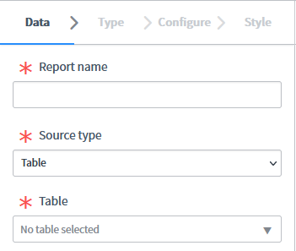
This tab is used to give the report a name and pick what table to run the report on. This will specify what data can be in the report. The most useful options are:
Task [task] – Will report on most everything, excluding a few particularly niche ticket types.
Requested Item [sc_req_item] – Will report on RITMs only.
Incident [incident] – Will report on INCs only.
Catalog Task [sc_task] – Will report on SCTASKs.
The more specific a table that is picked, the better you can filter and display the results you get.

Type
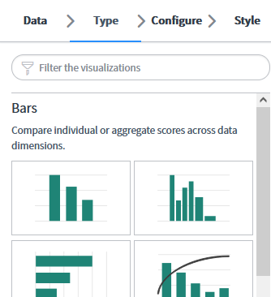
This tab specifies how the data will be presented. It includes most common types of data visualisation. The major categories are:
Bars – Self-explanatory, these are the same bar graphs you would have seen in school.
Pies and Donuts – Self-explanatory, these are the same pie charts you would have seen in school.
Time Series – Can plot data changes over time, meaning you can look for trends in data without having to run multiple reports.
Multidimensional Reports – I don’t understand how to use these in SNOW well enough to explain them, but they are useful to show a breakdown of the data across multiple variables.
Scores – Gives quick at-a-glance visualisations.
Other – Various specified data visualisations, the most immediately useful isn’t a graph though. The “List” option will give a straight export of all the tickets and the columns you specify in the “Configure” tab. “Box” and “Trendbox” are also useful but very niche in their use-cases.
There is another section in this document titled “Graph Types” that goes over when you may want to use certain types to represent data.

Configure
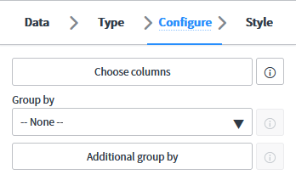
This tab changes depending on the type of report selected and is used to fine-tune the visualisation to make it show the data how you want, e.g. what trends to show or how to group columns.

Style
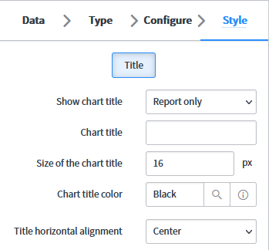
This tab changes depending on the type of report and is used to make superficial changes to the visualisation like colour.

Report Filter
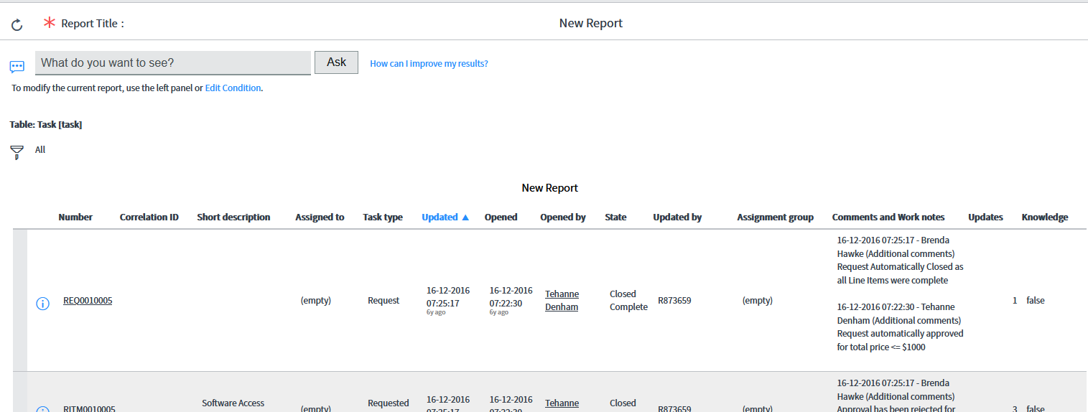
This pane is used to create the filter needed for the report. Whatever is put into this filter will remain when changing the report type but will not persist through changing the table being used. How to write filters will be elaborated on in the next section of this document.

Saving and Sharing Options

Here is where you can save and share the report. All reports must be saved before they can be shared and must be shared before anyone else will be able to view them.

Creating Filters
Filters are generally created by slowly whittling down a report from every ticket in the system by adding additional items to the filter until you are left with only the tickets which you are interested in.
The most immediately useful filters to quickly limit the results are:
- Ticket type
This is useful for very quickly knocking out things you know you aren’t interested in. As an example if you are using the Catalog Task table then you can use the “Request Item>Item” filter to limit it to one request type, e.g. if you only care about Software Access Requests you can limit the results so that Software Access Requests will be all that show up.
- State
This is useful to find only tickets that are either open or closed. An example is if you are interested in how many tickets are on hold, you don’t care about cases that are already closed.
- Assignment Group
A lot of the time you will only care about tasks assigned to a particular team, say Global Service Desk or the Citrix team. You can use “Assignment Group” to limit cases to only the teams you care about in the context of your report.
- Date Open/Closed

Exercises

“Simple”
- Incidents opened by a specific person this week.
- Open cases assigned to Citrix.
- Open incidents updated yesterday.
- Incidents that are resolved but not closed.
- Open tasks for a given catalog item.
- A graph showing the trend of incidents opened for the last year.
- The top 10 most used KBs for the last month.
- The top 5 most common request types raised for the last 6 months.
- Incidents that have been re-opened.

“Advanced”
- Users enrolled for password reset.
  - Will need a new table, finding this is left as an exercise for the reader.
- Top 10 Software Access Requests by software requested.
- Catalog Tasks that have no RITM.
  - At the time of writing there are just over 20 of these all-time as an estimate of what results you should see.
- Incidents opened from an email.
- Incidents opened by someone from Townsville.

Excel Reporting

Making tables
After exporting data from Service Now or any other system (Nexthink or Active Directory as an example) it will generally be formatted into a block of data that while colloquially called a “table”, Excel refers to as a “range”. The difference between tables and ranges in Excel is that tables can be used for data analysis through filtering or querying where a range is more like a simple block of data that is very limited in its applications.
To convert the data from a range to a table, click any cell in the range and click the “Format as Table” button which is in the centre of the “Home” (selected by default in Excel) ribbon:
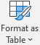
Select a colour scheme from the dropdown menu (this up to personal preference and has no impact on the functionality of the table) and a new “Create Table” window will appear. Excel should have automatically selected every cell in the range, but this is a good time to have a quick glance to make sure it did get all the rows/columns it needed to and correct if necessary. In the popup window the only option is “My table has headers,” select this if your data has headers built into the columns. If it doesn’t, make sure that you don’t select this option or your first row of data will be converted into headers and will be removed from the actual data.
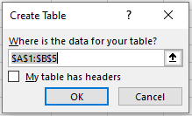

Making PivotTables
A PivotTable is a powerful data analysis tool that allows users to summarize, sort, filter and analyze large datasets by arranging information in meaningful ways. It helps identify trends, patterns, and correlations within the data set.
To make a PivotTable:
- Click on any cell inside your data table,
- Go to the “Insert” menu tab,
- Click “PivotTable”,
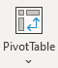
- Verify that Excel has surrounded your table with dotted line (and not missed any rows or columns),
- Leave the settings page as-is and click OK.
You should be directed to a new tab in the worksheet with a blank placeholder for a PivotTable and a new pane (“PivotTable Fields”) on the right of the screen.
The 5 fields in the pane are:
- Fields – This is a listing of all of the columns in your table.
- Filters – This can be used to add a changeable filter to the PivotTable so you can narrow down
- Columns – This field defines the columns in your PivotTable
- Rows – This field defines the rows in your PivotTable
- Values – This field defines what you would like to check for the combination of each row/column.
To place fields into the Filters, Columns, Rows, or Values section it is easiest to drag them from the Fields section to the section you want them to be in. They will remain in the top field (now ticked) and can be used in more than one section.
Below is an example usage to find what fruit a given person ate in a given month.
This is a table of dummy data with the columns “Fruit”, “Eaten By”, and “Eaten in Month”.
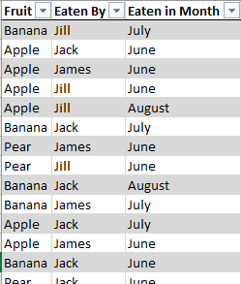
After making a PivotTable with the data I have chosen to arrange the data into names down the left-hand side (Rows), fruit types along the top (Columns), the values will be the count of fruit eaten for a given person/type (Values), and an optional filter for the month they were eaten in (Filters).
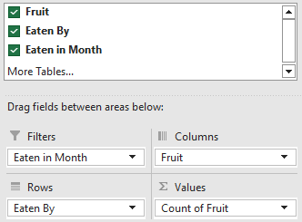
This result is the PivotTable below. The “(All)” drop-down next to the “Eaten in Month” heading in the top-left is where you could filter to a given month (e.g. “July”) and it would only count data from that month (based on the third column) in the values. The drop-downs next to “Row Labels” and “Column Labels” can be used to filter to only people/fruits we are interested in (e.g. I could filter to only “Jack”, “Apple”, and “Pear” to hide the “Banana” row and the “James” and “Jill” columns).
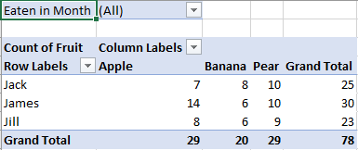

Making Graphs
Graphs are a good way to quickly relay data in a visual way, which makes them excellent to identify emerging trends. They are well suited to quickly getting people up to speed with information without having to walk them through the data itself and trying to explain it.
The simplest way to get a useful graph is to use the data from a PivotTable that already has the data you want organised in a readable way. The steps for doing this are as follows:
- Click into any field in the pivot table.
- Go to the “Insert” ribbon in Excel.
- In this ribbon, either select the “Recommended Charts” button to have a live-update preview of all the graph types or select one of the specific graph options from the smaller drop-down menus if you already know which graph you want.
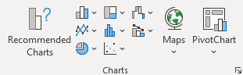
Once you have created the chart from the PivotTable, changing the fields in the PivotTable itself will automatically update the graph to match. Similarly, if you select the graph Below are a few examples of how you could present the data in graph form depending on what you are trying to show:
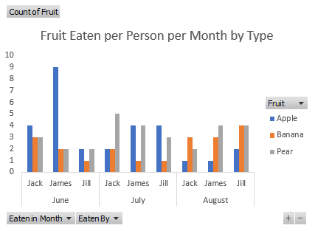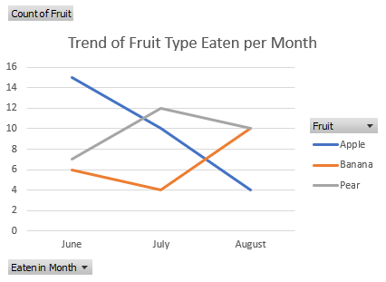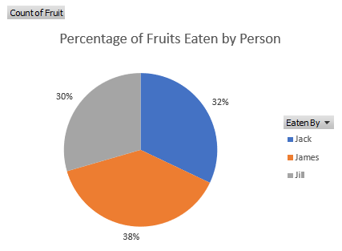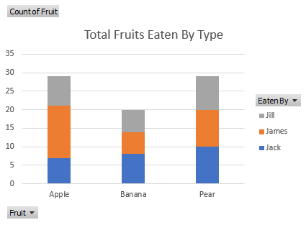

Making queries
A query is a way to make a complicated series of steps in an Excel spreadsheet simple and repeatable. Once a spreadsheet has queries set up to run on a data table in a spreadsheet it can be run any time the data in the table is updated. This is particularly useful for reports that need to be run on any sort of schedule by streamlining the processing of the data and standardising the output (i.e. it doesn’t vary in formatting between runs, only the actual data in the input is different).

Creating a query

Modifying data in a query

Saving a query, and the difference between saving queries to a table or a connection

Merging Queries
Require a sub-query/connection for each table to be merged to already be created.
Common column

Join Kind
XLOOKUP
XLOOKUP is a formula that can be used to quickly fill a cell with in one table with a value from a second table where the tables have some matching value.
An example would be a table that has the columns [USER ID] and [NAME], and a second table that has [USER ID] and [EMAIL]. We will call these “TableA” and “TableB”.
TableA |  |  | TableB
USER ID | NAME |  | USER ID | EMAIL
O123456 | Tim Curry |  | O123456 | tcurry@domain.com
R234567 | Steph Curry |  | O345678 | yum@domain.com
O345678 | Thai Red Curry |  | R234567 | stephc@domain.com

We can join these two tables using the USER ID column following the previous sections on queries, but as we know there will only be one row for each USER ID in each table an XLOOKUP is much quicker.
We can add a third column to TableA with the heading “EMAIL”:
TableA |  |  |  | TableB
USER ID | NAME | EMAIL |  | USER ID | EMAIL
O123456 | Tim Curry |  |  | O123456 | tcurry@domain.com
R234567 | Steph Curry |  |  | O345678 | yum@domain.com
O345678 | Thai Red Curry |  |  | R234567 | stephc@domain.com

In the first blank cell we will enter an XLOOKUP formula to find the corresponding value from TableB
To tell Excel you are entering a formula, enter “=” into the cell, immediately followed with XLOOKUP to tell it what formula we will be doing. Add a bracket “(“ and it will tell you what is needed inside the brackets for the formula to work
For this formula, we need a “lookup_value”, “lookup_array”, and a “return_array”. Anything inside square brackets “[]” is optional and we will ignore them for now.
The “lookup_value” is the value we are interested want to search TableB for, i.e. the USER ID. We can click on the first cell in the user ID column (“O123456”) for this, which will enter “[@[USER ID]]” automatically into the formula. The “@” means “the value on this row” and “[USER ID]” signifies in the USER ID column in the same table.
The “lookup_array” is the list of cells to look for the selected value in in the second table, i.e. the USER ID column in TableB. We can highlight all the cells in the USER ID column in TableB to fill this value with “TableB[USER ID]”, which means “search the USER ID column in TableB”.
The “return_array” is the list of cells to look for what value to return from the second table, i.e. the EMAIL column in TableB. We can highlight all the cells in the EMAIL column in TableB to fill this value with “TableB[EMAIL]”, which means “search the EMAIL column in TableB and put it display it in the XLOOKUP field”. Put a final “)” after this to finish the formula.
The full formula should now look like this:
=XLOOKUP([@[USER ID]],TableB[USER ID],TableB[EMAIL])
Upon hitting enter the formula should be replaced in the spreadsheet with the corresponding email address from TableB, and all the other blank cells in the EMAIL column of TableA should also have automatically filled with the formula and found the correct email address as well:
TableA |  |  |  | TableB
USER ID | NAME | EMAIL |  | USER ID | EMAIL
O123456 | Tim Curry | tcurry@domain.com |  | O123456 | tcurry@domain.com
R234567 | Steph Curry | stephc@domain.com |  | O345678 | yum@domain.com
O345678 | Thai Red Curry | yum@domain.com |  | R234567 | stephc@domain.com

Graph Types
This section will serve as a brief introduction to the most useful graph types, and example use-cases for each.

Bar Charts
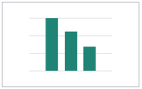
Bar charts are useful for visualizing categorical data, comparing groups, and showing trends over time. They are ideal for displaying discrete data points and highlighting differences between categories. Examples of when to use a bar chart include:
- Displaying the number of incidents raised per person.
- Showing the number of requests raised for different catalogue items.

Line Charts
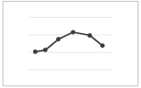
Line charts are best suited for visualizing continuous data over time, tracking trends, and demonstrating relationships between variables. Some situations where line charts would be preferred include:
- Tracking the number of incidents raised per over time.
- Displaying trends in the utilisation of certain request forms

Pivot Tables
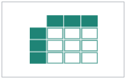
Pivot tables are interactive spreadsheet functions that allow users to quickly analyse, sort, filter, and group large amounts of data. They are particularly helpful for summarizing and organizing large datasets. Examples of when to use pivot tables include:
- Calculating the total revenue generated by a company's products over a period.
- Summarizing the performance of a sports team over multiple seasons.

Data Tables
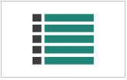
Data tables are static representations of data that can be easily sorted, filtered, and analysed manually. They are especially useful for small datasets or when dealing with textual data. Examples of when to use data tables include:
- Creating a list of employees along with their job titles and departments.
- Displaying the top 10 most frequently ordered items in a restaurant.

Box Plots
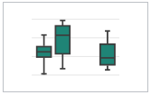
Box plots are graphical representations that show data distribution using five key values: minimum (lower quartile), lower quartile, median, upper quartile, and maximum (upper quartile). Whiskers extend from each end of the box indicating the range of possible values. Potential uses for box plots include:
- Visualizing and comparing distributions of multiple datasets.
- Assessing skewness or outliers in a given set of data.
- Quickly identifying trends or patterns in data over time.

Pie Charts
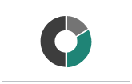
Pie charts are circular graphs divided into sectors whose angles correspond to frequencies or percentages represented by each category. They are primarily used to depict proportional parts of a whole set; however, they may not accurately reflect absolute magnitudes. Some scenarios where pie charts could be employed include:
- Displaying the breakdown of a company's revenue sources.
- Presenting the distribution of a population by age group.

Active Directory Queries (LDAP)
THIS SECTION IS ADVANCED AND REQUIRES A BASE-LEVEL UNDERSTANDING OF PROGRAMMING LOGIC

Service Desk (along with technically all users in QR) has the ability to query the Active Directory system directly to generate reports against various things using LDAP (Lightweight Directory Access Protocol). A few examples of things that are frequently requested are:
- People who have access to a specific group,
- People who don’t have an email address listed, and
- People who report to a specific manager.
LDAP queries are generated using a simple if-else programming structure but can be make for very specialised reports effectively when used effectively.
A simple example of a query is the following:
(&(objectClass=user)(|(samAccountName=O123456)(samAccountName=R123456))
This will find any user objects that have a login ID of “O123456” or “R123456”.
While AD requires the query to be on one line, for easy of readability this can be reformatted to the following:
(&
(objectClass=user)
(|
(samAccountName=O123456)
(samAccountName=R123456)
)
)
Which can be visualised as:
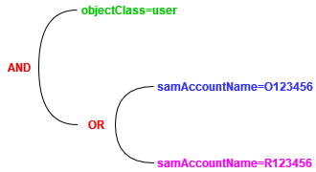
The three logical operators that can be used in LDAP queries are &, |, and !. These are AND, OR, and NOT respectively. These are used in the start of a pair of brackets (e.g. “(&(filter1)(filter2))”) and apply to all objects in the same pair of brackets. These can be nested as in the previous example.
Everything enclosed in “AND” (&) brackets requires an object to match everything underneath, and “OR” (|) brackets require that a minimum an object match a minimum of one rule inside the brackets. The previous example filter when put into plain English would be read as “find all objects that are user objects and have a login ID of either O123456 or R123456.”
Good resources for further reading on LDAP queries is THIS LINK for general guidance of how to use LDAP, and THIS LINK which has information on what the name of each field in Active Directory is according to LDAP when creating queries.

Links

Reports link
https://queenslandrail.service-now.com/nav_to.do?uri=%2Freport_home.do

Dashboards
https://queenslandrail.service-now.com/nav_to.do?uri=%2F$pa_dashboards_overview.do

